|  |
| --- |
| U.S. Drought Monitor |
| USDM Authoring |
| Training and Tutorial |

|  |
| --- |
| Curtis Riganti, Brie Paladino – NDMC  1-23-2025  Version 1.2 |

Contents

SELECTING 3

Polygons and Lines 3

How to select Dx polygons 3

EDITING 5

USDM Polygon Layers 5

Snapping 5

How to edit Dx polygon vertices 6

How to split Dx Polygons 9

How to create new Dx areas 11

How to Merge Dx Areas 16

How to cut a “donut hole” 21

How to delete a Dx polygon 24

Impact Lines, Labels, and Pointers 25

How to edit an impact line polygon 25

Editing Impact Labels 29

NAVIGATION 36

Going to a specific frame 36

Moving panels/windows around your ArcGIS Pro display 37

LAYOUT VIEW 40

Making changes to text in the USDM layout view 40

Making the explore cursor easier to find 43

Capturing the Screen to Clipboard 45

DATA VIEW 46

Repairing Data Sources 46

Fixing a data source that’s not labeled as being broken 47

Selecting/un-selecting multiple data layers at once 50

Turning labels on 52

Adding raw value point data and associated symbology 58

Turning labels on for point data: 62

Changing the symbology/importing symbology for a point data layer 67

Editing the symbology/color scale of raster data 75

Using the Rectangle Zoom Feature 77

# SELECTING

## Polygons and Lines

### How to select Dx polygons

Say we want to edit the D4 shapes:

1. Under the Drawing Order in the Table of Contents, open either Outlines or Shaded under USDM EDIT🡪Drought Areas

1. Right click the layer we want (D4), mouseover Selection, and click “Make this the only selectable layer”

1. Under the Map tab, go to “Select” in the Selection group, and pick your favorite selection strategy (mine is lasso)

1. If you’d like to clear the selection, click clear (also in the Selection group)

1. If you’d like to select something else, make that other thing the only selectable layer (in other words, repeat step 2)
2. Alternatively, like in ArcMap, with your selection tool, you can also double click inside the polygon you want to select in order to select it.

# EDITING

## USDM Polygon Layers

### Snapping

1. When editing, snapping is when you’re dragging a vertex around and the vertex automatically aligns with some point or feature, once you get close enough to said point or feature. To turn snapping on, go to the Edit tab and the snapping group and click on the Snapping icon.

1. To edit snapping preferences, click on the down pointed arrow at the bottom of the snapping icon, and click on snapping settings.

1. Here, you can change the pixel tolerance for how close you need to be (in units of pixels) in order for a snap to occur.

### How to edit Dx polygon vertices

1. See “How to select Dx polygons”
2. Once you’ve selected a line, go to the Edit tab, click the Edit button in the Manage Edits group, and then select the desired editing (in this first example, we’re going to edit vertices, the most common thing you’ll be doing)



1. Once you’ve clicked Edit Vertices, vertices will show up as empty boxes. You can click and hold down over these boxes and drag them wherever you’d like. A red and black background with green squares

   Description automatically generated

*Changing multiple vertices:* Alternatively, you can use one of the select tools to select multiple vertices, right click on one of them, and delete in bulk (you can also delete selected vertices using the delete button on your keyboard). Finally, like in ArcMap, there are widgets for adding vertices and deleting individual vertices. When Edit Vertices is turned on, you can click on one of these in the lower-center of your screen.

*Adding vertices:* As an example of how to use the add vertices tool, you can select the add vertices pointer (the one with the +), left-click and drag on a free spot on the boundary of the polygon, and release where you want the new vertex to be (same functionality as in ArcMap).

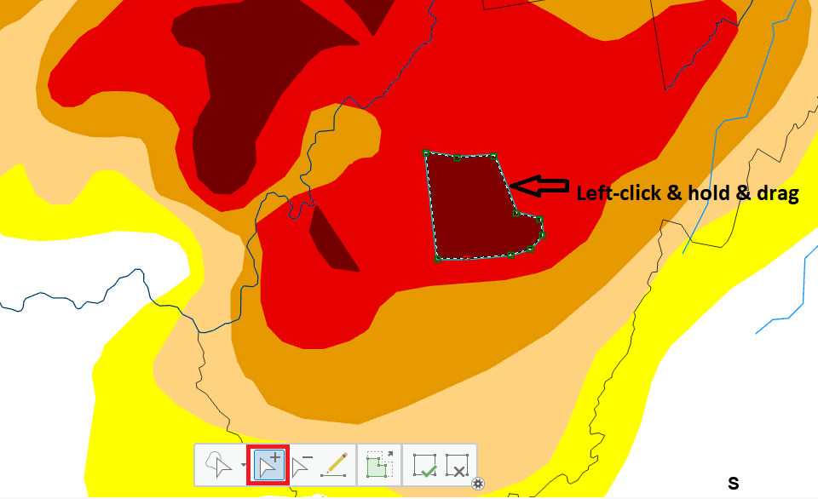

1. When you’re done dragging vertices, either select outside of the polygon you just edited, or clear selection (see Selection group). If the save button (Manage Edits group) is already highlighted, you don’t have to clear selection. Save your edits (this saves the shapefile that you’re editing).

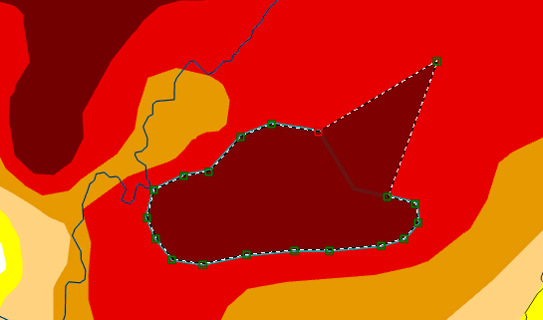

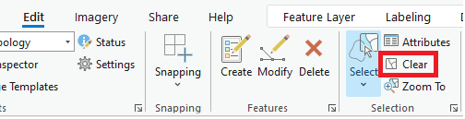

### How to split Dx Polygons

1. Select the Dx polygon that you want to split (see “How to select Dx Polygons”)
2. From the Tools group under the Edit tab, click the Split button

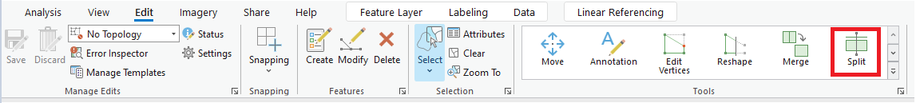

1. Single click on one side of the polygon, and then double click on the other side, making sure that the dashed line cuts all the way across the shape (i.e., starting and ending outside of the polygon while crossing its outer edge twice in between the start and end points).

1. Once you’ve double-clicked, the old polygon will now be split into two pieces. Select (see How to select Dx polygons) one of the polygons and edit its vertices and save edits (see How to edit Dx polygon vertices) as desired.

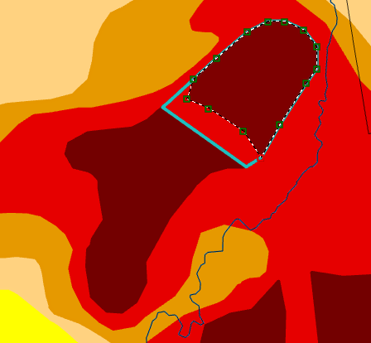

### How to create new Dx areas

1. Make the Dx level for which you’re drawing a new area the only selectable layer (see How to select Dx polygons).
2. Turn on the Edit button in the Manage Edits group under the Edit tab.

1. Click the Create button in the Features group under the Edit tab

When you click this, a Create Features window should pop up on the right side of your screen.

Let’s say we want to add another D4 area. Click on the D4 Outlines symbol:

Once you’ve clicked the D4 outline symbol, the view should change. Make sure, within the new view, that the polygon symbol is highlighted (see blue box):

1. Single click where you want your first vertex to go, then single click with each subsequent vertex.

Once you’re done adding vertices, double click to add the last vertex.

Now, after you’ve double clicked, the screen should look like so:

1. Clear selection and save, or select outside of the newly-created polygon and save (see step 4 of How to edit Dx polygon vertices).

### How to Merge Dx Areas

1. Make sure you’ve selected the Dx polygon level that you want to merge (see How to select Dx polygons) and that the Edit button in the Manage Edits group under the Edit tab is turned on.

1. Edit vertices (see How to edit Dx polygon vertices) such that polygons of equal level overlay each other (in this example, we’re again using D4, because our Wx/Dx levels go to 11 😉 ). *Note*: Another way to do this is to create a new D4 polygon that bridges this gap and jump ahead to step 3 (in which you’d select 3 polygons, not 2). See How to create new Dx areas for that.

After selecting outside of the D4 polygons or clearing selection, it’ll look like this

1. Using your preferred selection widget (again, I like “Lasso”), select both D4 polygons:

1. In the Tools group under the Edit tab, click Merge.

1. A Modify Features window will show up on the right side of your screen. The selected features to merge will appear (make sure the Layer field is correct (see blue box below). Click the Merge button (red box below) in the lower right corner.

1. If you want to verify that these were merged correctly, use your preferred selection tool to encircle the former two polygons, and make sure that there is now just a single outline where before there were two.

### How to cut a “donut hole”

1. Select the Dx area you want to cut a donut hole in (see How to select Dx polygons).
2. Turn on the Split tool in the Tools group under the Edit tab

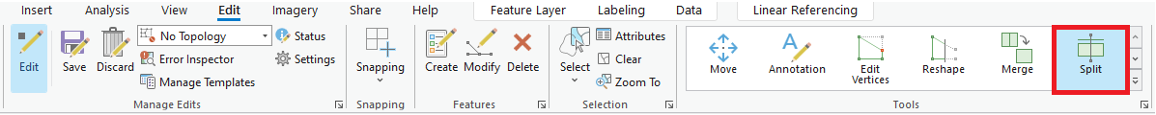

1. Single click to start your cut/split, and start tracing out the shape you want to cut out:

1. With your last leg/vertex, fully cross over another leg and double click. The enclosed shape you’ve created by doing this will be the “donut hole”. You can think of it like layers of construction paper, where you’ve sliced out with scissors a segment of D4, and pulled out the now loose paper, leaving the D3 visible below.

After double clicking, it should look like this:

1. Using your favorite selection tool (again, I like “Lasso”), select only the inner (now loose) shape that you intend to pull out

When releasing the mouse to select the inner area, it should look like this now:

1. Now that you’ve got the loose cut-out selected, hit the delete button on your keyboard.

### How to delete a Dx polygon

1. Select the Dx area you want to delete (see How to select a Dx polygon); if using lasso …

Release mouse

1. To verify that you’ve selected the area you want to delete and *only that*, Zoom To the selection (in the Selection group under the Map tab).

Make sure that this goes to the correct place, rather than zooming out and showing multiple spurious selections! If you’ve selected the wrong thing, or too much, clear selection, and make sure that you’ve made the right thing the only selectable layer (again, see How to select a Dx polygon)

1. After double-checking that you’ve got the right thing selected, hit the delete key on your keyboard. This should get rid of the donut.

## Impact Lines, Labels, and Pointers

### How to edit an impact line polygon

1. First, you need to select the polygon. In Contents under Drawing Order, right-click on Impact-Polygons under “IMPACTS”, mouseover Selection, then click “Make this the only selectable layer”.

Go to the Edit tab, and pick a selection tool from Select in the Selection group (in my examples, I’ve been using lasso, but you can use any of them).

Staying in the Edit tab, click the Edit button in the Manage Edits group. Then, click the Edit Vertices button.



Use your selection tool to select the polygon (in the case of lasso, simply draw a lasso inside of or touching at any point the polygon that you wish to edit, then release the mouse and the vertices will appear).

Lasso example:

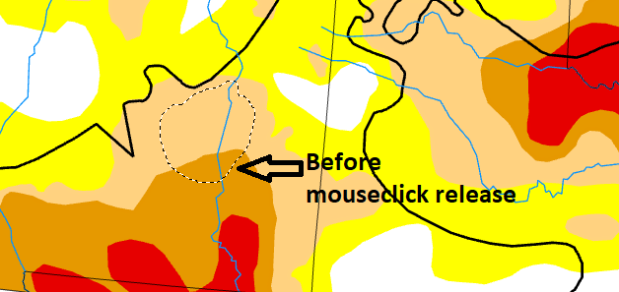

1. Using the editing vertices tools at the bottom-center of your screen, edit the vertices as desired. This works the same way as editing Dx polygons (see How to edit Dx polygon vertices)

1. When finished editing, either select outside of the polygon, or click the Clear button in the Selection group under the Edit tab.

Finally, save your edits by clicking on the Save button in the Manage Edits group under the Edit tab.

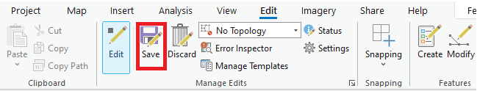

### Editing Impact Labels

1. Make Impact SL the only selectable layer (like we’d do with other Dx layers).

1. Turn on the Edit button and grab your favorite selection tool.

1. To move an impact label, select it, then turn on Edit Vertices or the Move tool in the Tools group under the edit tab, and drag the impact label to where you want to put it, release mouseclick, and save edits.

1. To change the type of label it is, select the label, then right-click it and click on the Attributes option.

1. Type the new label next to Type, under Attributes:

1. To create a new impact label from scratch, make sure the Edit button in the Manage Edits group (under the Edit tab) is turned on. Go to your Create Features window (if you can’t find it, search for it with the search bar at the top center of your ArcGIS Pro window). Click Impact Label.

1. When moving your cursor back over the map, it’ll turn into a plus sign/crosshairs symbol. Left-click where you want to put your new label (doing this will put a light blue circle in that location). Then, with a selection tool, right-click on your new label, click Attributes, and edit the Attributes text (as explained above in step 6). Then, click the Apply button. Finally, save edits (save button back up in the Manage Edits group).

1. Finally, you can also just copy/paste impact labels. To do this, make sure the Edit button in the Manage Edits group is on. Use your favorite selection tool to select the impact label you want to copy. Select it, then control-C on your keyboard. Then, control-V. You’ll see a yellow circle pop up on the screen (this represents the pasted impact label, on top of the original). A screenshot of a computer

   Description automatically generated

The Move tool in the tools group should also be automatically selected once you’ve done this. Click and drag on the yellow circle until it’s where you want it to go, then release. Save edits and clear selection. It may take a bit of time, but the new impact label is there and will eventually show up.

**Undoing an Edit**

1. If you made an edit/shifted lines that you did not want to, *do not press the save button.*
2. In order to undo a single edit (as opposed to all edits made since the last time you hit save), Ctrl+Z on your keyboard.
3. In order to undo all edits since the last time you hit save, click the Discard button in the Manage Edits group under the Edit tab. This will undo all edits you’ve made since you last saved your shapefile with the Save button in the Manage Edits group.

# NAVIGATION

## Going to a specific frame

First, *to go to the Layout view* in the APRX, find the set of tabs above your map viewer. Click the one with the Map Series style icon rather than the Map Frame style icons.

*To go to different geographic views*, such as CONUS, Puerto Rico, Alaska, and Hawaii, click on one of those tabs.

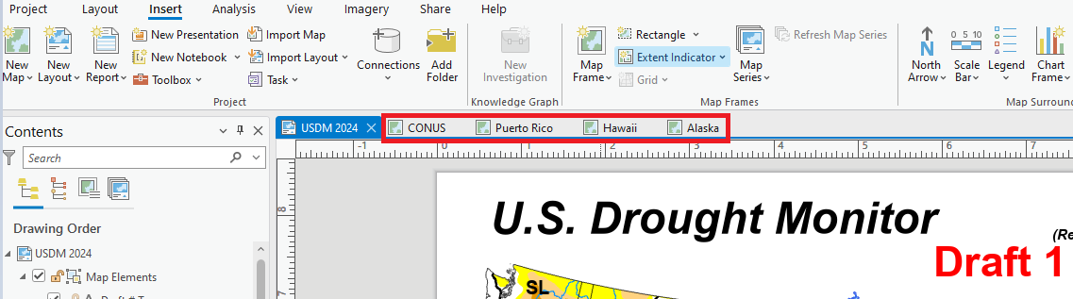

## Moving panels/windows around your ArcGIS Pro display

1. The panels/windows in your ArcGIS Pro display can be moved around to different parts of the screen. For example, lets say that we wanted to stack the Contents panel next to the Modify Features panel. To do this, left-click on the top bar of the Contents panel and begin to drag it across the screen to the right.

1. See the alignment items that come up on the screen. To align the window you’re dragging as one of those, keep dragging and move your mouse over the alignment tab, then release your mouse.

1. If you stack things on top of each other, such that, for instance, the Contents window is brought into the Modify Features window, you can undo this by going to the bottom of the window in question, right clicking on the window you want to free, and clicking Float.

# LAYOUT VIEW

## Making changes to text in the USDM layout view

**(author name, dates, draft numbers, etc)**

1. In the tabs above the map, click on USDM tab (the layout one as opposed to the different map frames).
2. Under the drawing order, click the dropdown arrow on the Map Elements.

1. Double-click the element that you want to edit (in this example, the author name)

The field you want to edit will then become selected; double-click the text field (in this case, the name “Brian Fuchs”) and that’ll highlight the text itself, then type away. We’re calling in former Nebraska football coach Tom Osborne from the bullpen for this example.

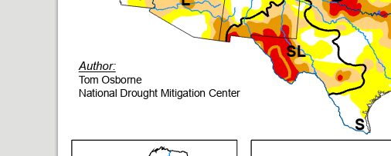

Click the save project button in the upper-left corner of your computer screen to save the change.

### Making the explore cursor easier to find

1. Go up to the upper-left corner of the screen and right-click around the document management buttons.

1. Click “Customize Quick Access Toolbar…”

1. For the “Options” window that pops up in the middle of the screen, make sure “Quick Access Toolbar” is selected (1), then select “Explore (Navigate/Identify…)” (2), Add (3) and OK (4).

1. Now the toolbar should have an Explore button saved; save the APRX to make sure this is kept. A screenshot of a computer

   Description automatically generated

### Capturing the Screen to Clipboard

Go to the share tab at the top of the page. In the Output group, click Capture to Clipboard. This will copy the image in the visible extent of the layout to your clipboard.

In the above example, the USDM draft map would be captured, and could be pasted into Paint, Microsoft Word, etc.

# DATA VIEW

### Repairing Data Sources

If you see a red exclamation mark show up next to the data you want to plot (in the Table of Contents), the data source needs to be repaired. To do this, first, click on the red exclamation mark:

This will bring up a file explorer window within ArcGIS Pro, which should be named “Change data source”. Select the relevant shapefile (or other type) for the data that you want to plot for the data-name in question (in this case, 60 Day SPI is named 60d_SPI_point.shp), so click that and then click OK.

A repairing broken data sources window will pop up on its own, as either the single source, or multiple data sources, will be repaired when you do this (I haven’t figured out the rhyme/reason for which occurs when).

### Fixing a data source that’s not labeled as being broken

If a data source isn’t broken (i.e., there isn’t a red exclamation mark next to the source in the Table of Contents), but rather the data aren’t displaying properly, it’s possible that the data layer in the Table of Contents is pointing to the wrong file. Go to the Table of Contents (I usually keep this in Drawing Order), right click on the layer in question (in this case, Vapor Pressure), and click Properties.

In the resulting pop-up window, click Source on the left, then check the Data Source to see if it’s the correct file (in this example, it isn’t). Assuming it’s not, then click “Set Data Source…”.

In the next pop-up window, navigate to and click the correct file, then click OK.

After clicking OK, a temporary pop-up will tell you that the computer is updating the data source.

Once finished, this window will go away on its own. Now, click Apply to apply the change in data sources to the document after checking that the new data source is the correct one.

### Selecting/un-selecting multiple data layers at once

In the Contents (under Drawing Order, for example), if you want to select or un-select multiple layers (on the same level) at once, Ctrl+click on a check-box. That layer and each other (on the same level) will be selected/un-selected. In this example, we start with each of the shaded Dx levels turned on. Ctrl-click on any of the Dx levels to turn each off. Alternatively, you can un-check the box above those levels (in this example, the “Shaded” box).

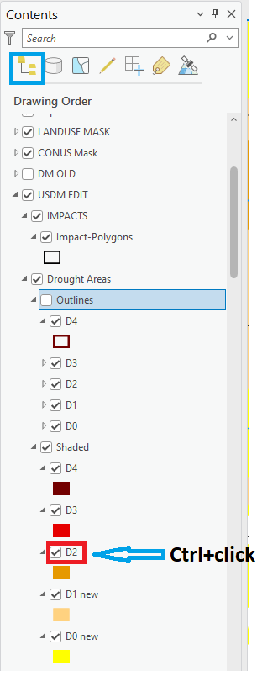

**Finding/reopening windows that you accidentally closed**

If you accidentally closed a window (such as, for example, the table of contents), generally speaking, the best way to find it/reopen it is to search for the thing in the search bar at the top of your ArcGIS Pro window.

If/when you see the option you want show up while typing into the search bar, click on it.

### Turning labels on

To turn labels on for a particular entity (for example, counties from a county shapefile), right-click on the layer in the Table of Contents (under Drawing Order), then click Label. If labeling is already set up properly, the labels should immediately appear.

If you want to change what field is labeled in a layer (this can also be useful for plotting streamflow and SP(E)I, click “Labeling Properties…” instead of Label. Say, for example, we wanted to plot FIPS codes as county labels rather than the name of the county for some reason. Upon clicking “Labeling Properties…”, a “Label Class” window should pop up on the right side of your screen. In this example, under Fields, double-click FIPS rather than County.

After double-clicking FIPS, it’ll show up as an expression now. Once you’ve got the field you want in the Expression window (you can select text and delete it out of the Expression window, too), click Apply.

Upon clicking, the labels should change. If there are no labels, right click on the layer in the Table of Contents and click Label (see earlier in this section).

**Locating Geographic Locations/Features on your map**

If you want to locate somewhere in your map (say you’re trying to cross-reference a CMOR report, for example), go to the Map tab and to the Inquiry group. Click Locate. When you click Locate, a search bar will pop up, likely on the right side of your screen.

Search for the geographic entity you want to find. In this first example, I’m pretending that I’ve received a CMOR report from the operator of Abie’s Place, a restaurant in tiny Abie, NE, that their well has run dry for the first time in 50 years. If I want to geolocate where Abie’s Place is and plot it next to other USDM data input types, I’d search for Abie’s Place in the search bar (in the blue box in the above screen-capture).

For this example, I’d click on Abies Place to plot its location.

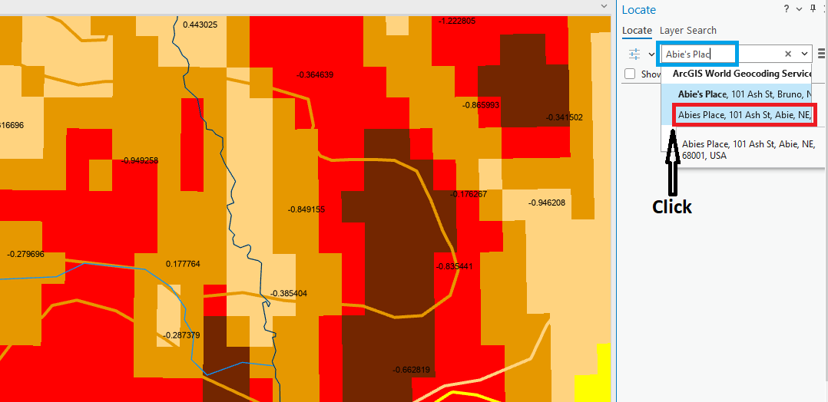

When you click the location you want to plot, ArcGIS will initially zoom way in; you can use your roll on your mouse to zoom back out.

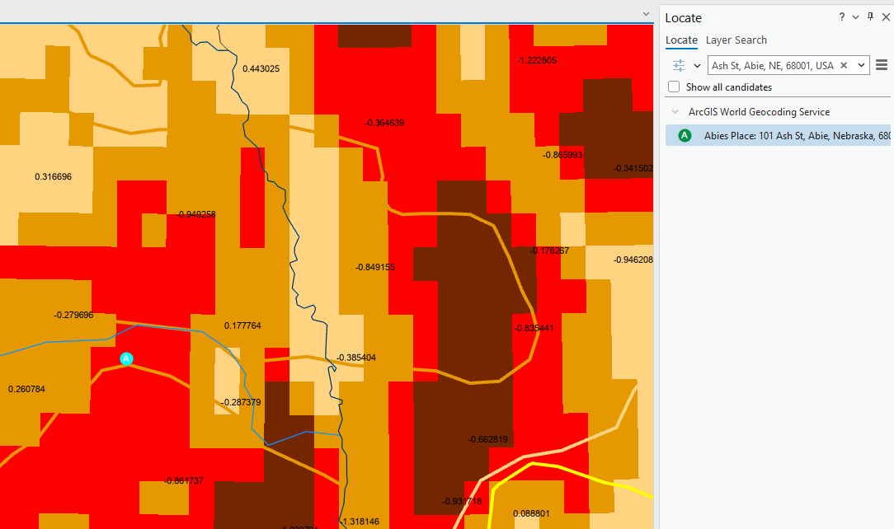

To remove the geo-location and close out of the Locate tool, simply close out of the Locate tool (X in the upper right of the above screen capture). Alternatively, if you want to leave the locate bar open but remove a location dot, X out of the search you did (see below screen capture).

Example 2: A recent visitor to the World’s Largest Porch Swing reported a dust storm while they were sitting on the swing, making it a less than pleasant experience. They realized that, given the recent very hot, dry, and windy weather in south-central Nebraska, that this was likely a drought impact, and submitted it to CMOR and provided lat/lon coordinates. You can search with lat/lon coordinates in the Locate tool, too.

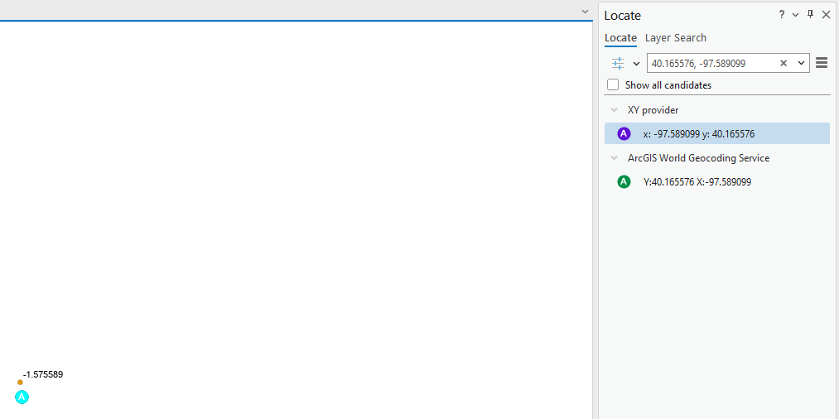

You can also quickly search for/jump to counties, which may be useful when authoring if you can’t find a county by perusing through labels (say, in Texas). In this example, let’s say we just finished making some changes in Oregon late Wednesday morning, and then received an email from the Nebraska group asking specifically about a change we made in Butler County, NE. If you don’t want to pan across the map until you find Butler County, you can use the Locate tool and search for the county name and click the county.

### Adding raw value point data and associated symbology

In this example, we are going to add CoCoRaHs precipitation data to our APRX. *Please note that this set of directions is at least partially unique to files that are located on your computer or a server you’re directly referencing.*

1. First, find the files that you want to add from your computer. Select them, and drag them over to the Table of Contents (you can really put it anywhere there, but it’s best to place it in the spot that you’ll ultimately want the data).

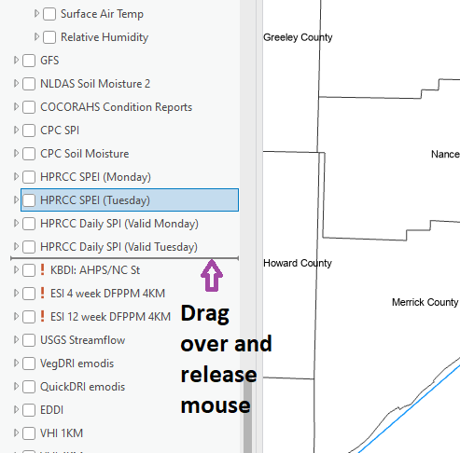

1. Once the new data are in, right click on the data group layer above (in this case, “HPRCC Daily SPI (Valid Tuesday)”)

Once you’ve done this, expand the group layer you right-clicked.

Now you should see the new group layer that you created.

Click on the name “New Group Layer” and re-name it.

Once it’s renamed, click on the group layer, hold, and drag it out of HPRCC Daily SPI (Valid Tuesday) downward, and then push it left to the same horizontal level as HPRCC Daily SPI (Valid Tuesday), then release the mouse (represented by the purple arrow)

Next, click one of the CoCoRaHs precip data layers (in the below example, sevenDay), hold the mouse button down, drag it into CoCoRaHs Precipitation, and release mouse.

Now, do the same with the other data layers so that all of the CoCoRaHsPrecip layers are in the CoCoRaHs Precipitation Group Layer.

### Turning labels on for point data:

To turn labels on for point data, right click on the data layer in question and click “Labeling Properties…”.

A Label Class window should appear on the right side of your screen.

Go to the Expression section of the Label Class window, click there, and delete/backspace/select and delete (however you prefer) to get rid of the default label if there is one and if it’s not the one you want.

Assuming the correct expression for the label shows up in the Expression box, click Apply.

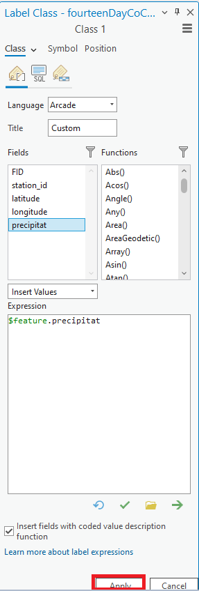

If no labels show up, check to see if the layer box (or it’s parent group) is checked, and make sure labeling is enabled.

### Changing the symbology/importing symbology for a point data layer

1. In order to change the symbology of a point data layer, right-click on the data layer in the Table of Contents, then click “Symbology”.

1. A Symbology window will show up on the right side of the screen. Now you have a few options …
   1. First, if you want to import the symbology from another layer: click the 3 horizontal bars in the upper right corner of the Symbology window, then click “Import Symbology…”

A Geoprocessing window will appear. Keep the input layer the same, and then select a symbology layer (one that you want to grab symbology from).

Once you’ve got your dropdowns ready, Run.

* 1. To edit already existing symbology, go to Symbology after right clicking the layer in the Table of Contents (see step 1). In order to do the DM percentile or SPI/SPEI index color intervals, you’ll want to make sure Manual Interval is selected in the Method dropdown.

To edit the max value to be labeled in a particular color, double-click on any of the cells in the Upper value column and type in the desired new number.

To edit the color of any of the symbols, right click on the relevant Symbol cell.

To change the symbol itself, normal/left-click on the symbol grid cell. Then click on the next symbol that you want to use.

### Editing the symbology/color scale of raster data

1. In the Table of Contents, right-click on layer which you want to change the symbology for (in this example, we’re using the current version of the Ensemble of NLDAS2 soil moisture). Then, click Symbology.

1. Once you’ve clicked Symbology, a symbology window will show up on the right side of your screen. Click on one of the color boxes to change any of the colors, and double click on any of the numbers and type away to change them.

### Using the Rectangle Zoom Feature

**Setting up rectangle zoom-in**

1. Go to the top of the screen and click on the little dropdown arrow.

1. Click Rectangle Zoom In. This will add it to the quick access toolbar.

1. Click the new icon to get the rectangle zoom tool.

1. With the magnifying glass as your cursor, draw a rectangle around the area you want to zoom in on (in my case, Nebraska, of course). A screenshot of a computer screen

   Description automatically generated
2. You’re now zoomed in on Nebraska; note in the upper left corner that your rectangle zoom tool is still in use. Click on the panning tool (in red box) to get out of the rectangle zoom tool.

***Added Stuff in Late January by Curtis (sort this into sections)***